My Guitar Shop exercises.docx Murach’s SQL Server 2012
6. Create a trigger named Products_UPDATE that checks the new value for the DiscountPercent column of the Products table. This trigger should raise an appropriate error if the discount percent is greater than 100 or less than 0.
If the new discount percent is between 0 and 1, this trigger should modify the new discount percent by multiplying it by 100. That way, a discount percent of .2 becomes 20.
Test this trigger with an appropriate UPDATE statement.
8. Create a table named ProductsAudit. This table should have all columns of the Products table, except the Description column. Also, it should have an AuditID column for its primary key, and the DateAdded column should be changed to DateUpdated.
Create a trigger named Products_UPDATE. This trigger should insert the old data about the product into the ProductsAudit table after the row is updated.
Then, test this trigger with an appropriate UPDATE statement.
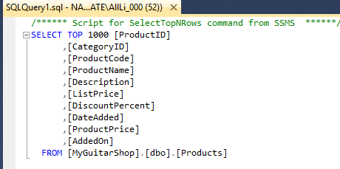
This lists the original columns on the Products table.

